Specification
  - Extrusion: TRIANG 19
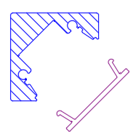

- The extrusion shall be made of aluminum alloy EN AW 6061.
- The extrusion shall be available in following surface finishes:
  - Blank
  - Anodized natural (thickness 15µm)
  - Anodized black (thickness 15µm)
  - Coated with polyester powder-coating in all standard RAL-colors
- The extrusion shall have following dimensions: 19mm x 19mm.
- The angle between the surface to position the PCB and the surface to mount the profile shall be an angle of 45°.
- The extrusion shall fit a PCB with a width of maximum 10mm.
- The extrusion shall be available in lengths up to 6m.
- The extrusion shall be compatible with an extruded PMMA cover.
- The extrusion shall have a compatible fully closed endcap.
- The extrusion shall have a compatible endcap with a hole for a cable.

